RAY TRACING

-Medha Kant

The scene as mentioned was laid out and each tube light was treated as four-point source. The camera initially lies at (0,0,6), Z axis begin coming out from the screen. Recursive depth of 4 was used for ray tracing and 5 rays were used for anti-aliasing. Also the model was lighted up using Blinn/Phong model and later Cook/Torrance model was used for snow.

Below are some of the screen shots taken from the initial camera position at 1000\*1000 window size and field of view 60 degrees.

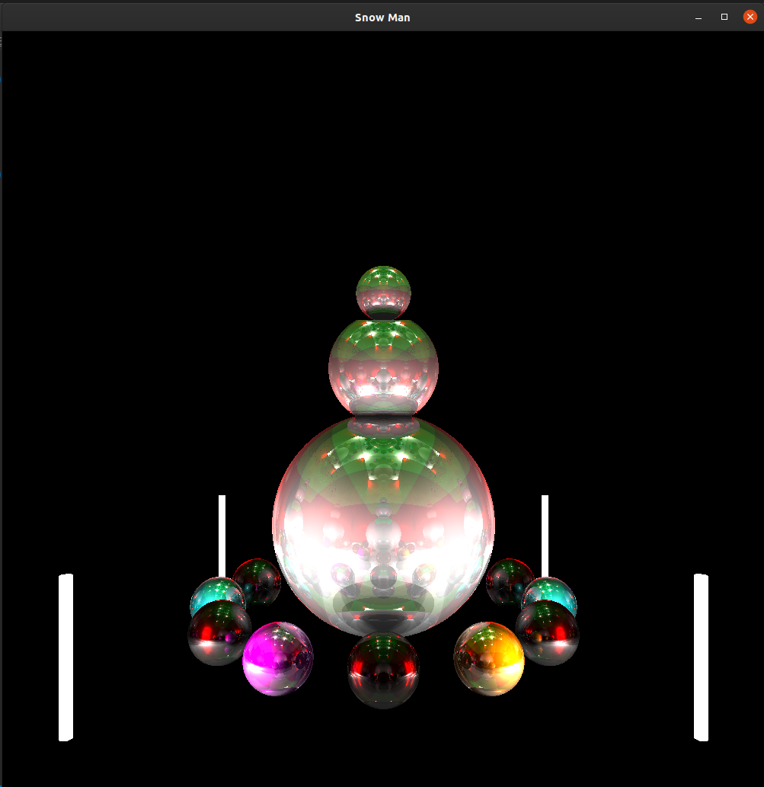

Without Anti-Aliasing and just using the Blinn/Phong illumination model.

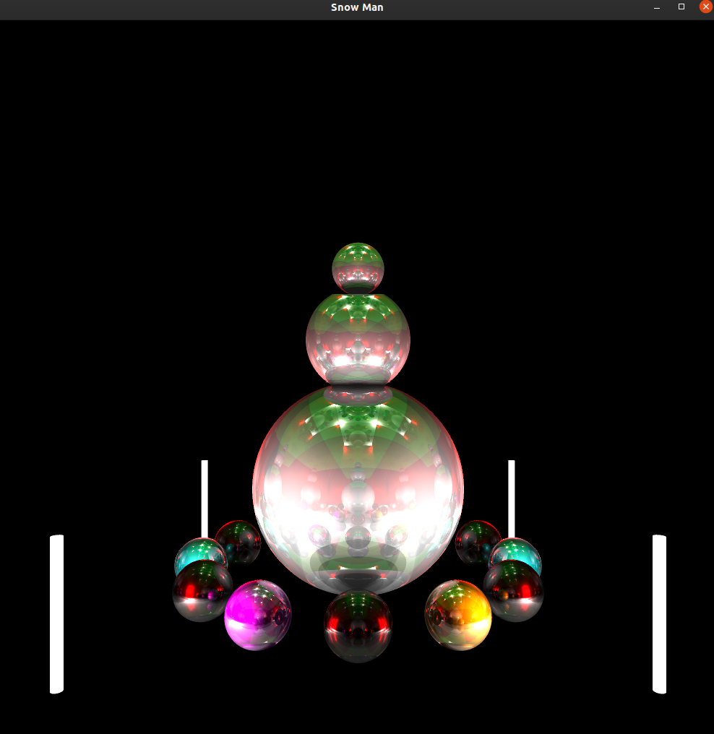

With 5x Anti-Aliasing and just using the Blinn/Phong illumination model.

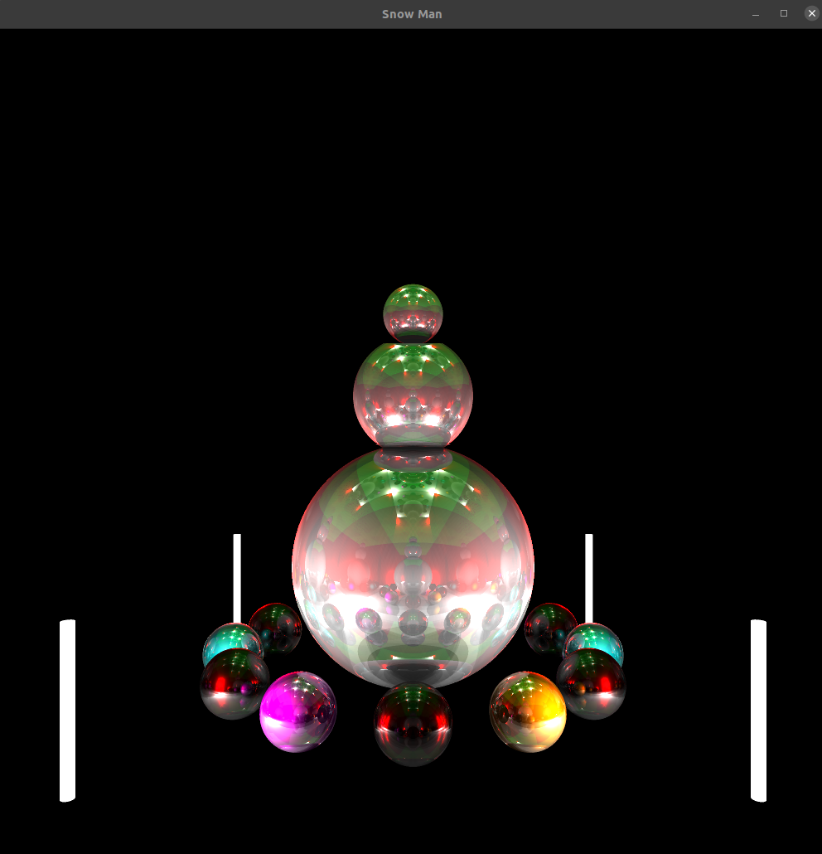

With 5x Anti-Aliasing and just using the Blinn/Phong + Cook/Torrance illumination model. (Cook/Torrance model only used for snow).

To run the program, run the makefile and make sure the system has GLEW and GLFW installed and added to PATH. The makefile produces an executable named snowman.